SEO Analysis Tool

“SEO Analysis Tool” is a web application that allows to analyze provided text or URL according to SEO methodology. The application provides following functionality:

- filter out stop-words (e.g. ‘or’, ‘and’, ‘a’, ‘the’ etc) from results

- calculate number of occurrences on the page of each word

- calculate number of occurrences of each word listed in meta tags

- calculate number of external links in the text.

There is a textbox to input text or appropriate URL to get it analyzed. There are 4 available checkboxes to turn on functionalities mentioned above.

Analyzed data is shown in a table below the input field and checkboxes.

How it works

On the page user can input text or URL. After the text or URL inserted the user can turn on or off available options with checkboxes (all checkboxes are checked by default). Then the user should clicks “Submit” button to get analyzed result.

Result is reflected in 4 tabs, each tab contains a table with appropriate result according to selected options (see below).

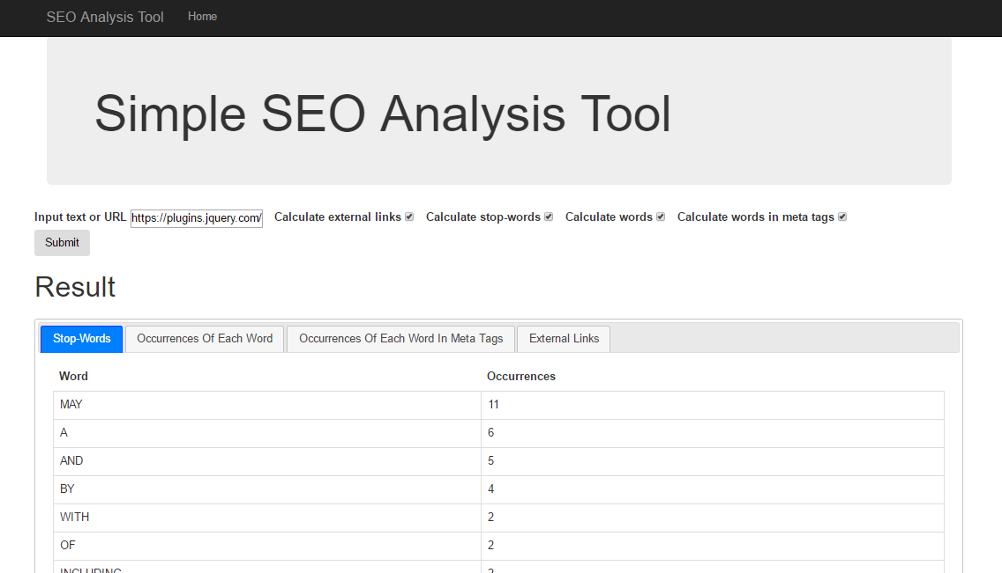

Main page of the app